**Measurement Systems**

**LAB 4: Design of pulse and frequency counter circuit.**

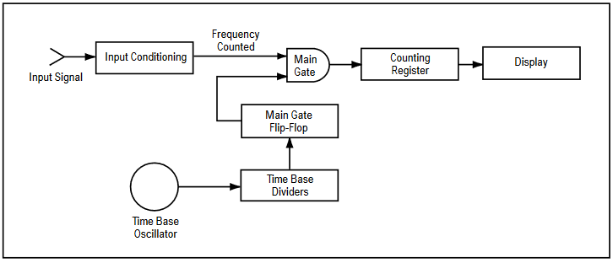

**Input**

When the input signal with high input impedance and low output impedance is applied to this counter, then it will be fed to the amplifier to convert the signal into a square wave or rectangular wave for processing within the digital circuit. The input signal is buffered and amplified by using the input conditions and thresholds. In this stage, Schmitt trigger is used to control the counting additional pulses occurred due to noise at the edges. To reduce the counting additional pulses, the trigger level and sensitivity of the counter can be controlled.

**Clock (Accurate Time-base)**

Clock or accurate time-base is necessary to produce various timing signals at precise time intervals. It uses a [crystal oscillator](https://www.elprocus.com/crystal-oscillator-circuit-and-working/) with high quality for controlled and accurate timing signals. The clock is applied to decade dividers.

#### Decade Dividers and Flip-Flop

Pulses generated from the incoming signal and clock signal are fed to the decade dividers to divide the clock signal and the output is given to the flip-flop to produce enabling pulse for the main [AND gate](https://www.elprocus.com/basic-logic-gates-with-truth-tables/).

#### Gate

The accurate enabling pulse from the flip-flop and the train of pulses from the input signal is applied to the gate ( AND gate ) to produce a series of pulses at a precise time interval. If the input signal/incoming signal is at 1 MHZ and for the 1-second gate should be opened, then 1 million pulses are produced as a resultant output signal.

#### Counter or Latch

The output of the gate is fed to the counter to count the no.of pulses that occurred from the input signal. The latch is used to hold the output signal while displaying the figures, meanwhile, the counter counts the pulses. It will have 10 stages to count and hold the pulses.

#### Display

The output of the counter and the latch are given to the display to provide the output in a readable format. The frequency of the output signal is displayed. The most commonly used displays are LCD or LED. Since there will be one digit for each decade counter and the related information is displayed on the display.